Contents

1) Introduction 2

2) Getting to the module 2

2.1) Entering medications that the patient is currently under (Med Entry) 3

2.1.1) Enter medications that a patient is currently taking prescribed by other doctors. 3

2.1.2) Importing medication from Sure Scripts. 6

2.2) Prescribing new drugs (Compose Rx) 8

2.2.1) Prescription writing 8

2.2.2) Sending prescriptions (Print) 12

2.2.3) Sending prescriptions (Electronic) 14

2.3) Allergies 20

2.4) Handling renewals 24

2.4.1) Receive refill requests from pharmacy. 24

2.5) Other features 25

2.5.1) Automatic features 25

2.5.2)To add a health plan manually 25

2.5.3) Reporting and retransmitting missing prescriptions 29

2.5.4) How to create and use drug sets 31

2.5.5) Adding or editing location pharmacy details 34

2.5.6) Leaving for staff processing 35

2.5.7) Leaving for doctors approval 36

2.5.8) Other features under the ‘Admin’ tab in the Prescription page 39

3. FAQ 41

# Introduction

The user can use this feature to do the following:

1. Enter medications that a patient is currently taking prescribed by other doctors.
2. Import medication from Sure Scripts.
3. Prescribe medicines electronically and through paper.
4. Refill medications and also receive refill requests from pharmacy.
5. Add Allergy information
6. This module will also automatically show you

* Drug to Drug interactions.
* Drug to allergy interactions.
* Drug Formulary Information.

We will get into all these features and some others also as we get into the module.

# Getting to the module

We will get into the functioning of the prescription module in 5 sections.

1. Med Entry
2. Compose Rx
3. Allergies
4. Handling renewals.
5. Other features

## 2.1) Entering medications that the patient is currently under (Med Entry)

Med Entry takes care of the following features

1. Enter medications that a patient is currently taking prescribed by other doctors.
2. Import medication from Sure Scripts.

### 2.1.1) Enter medications that a patient is currently taking prescribed by other doctors.

**Step 1**:- In the patient chart, click the ‘NewCrop MedEntry’ icon.

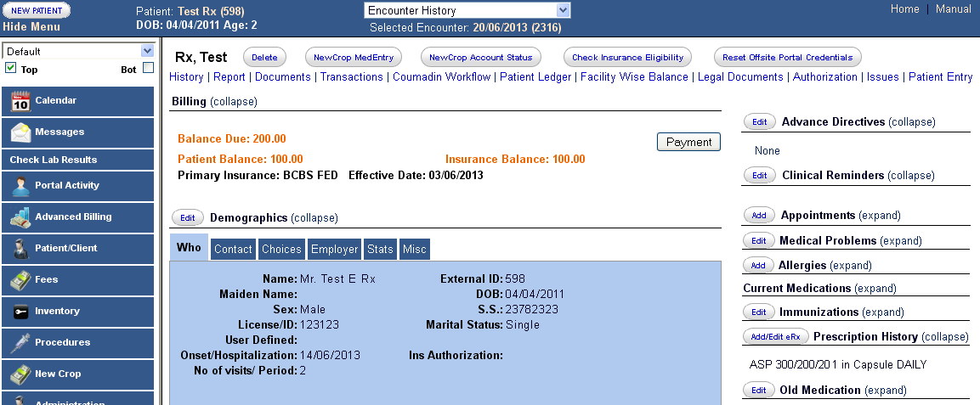

We get to the ‘Med Entry’ page

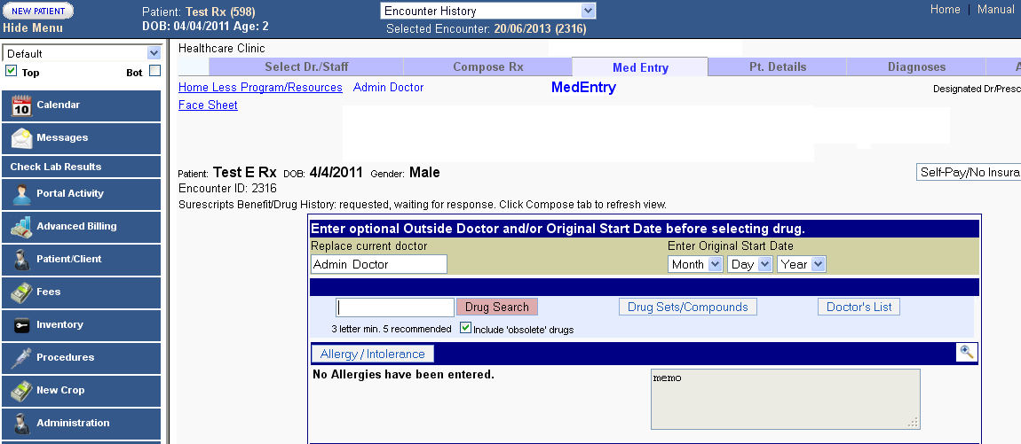

**Step 2**: - We can manually enter the drugs that the patient is currently taking.

Enter 3 to 5 letters of the name of the medicine and hit the ‘Drug search’ tab.

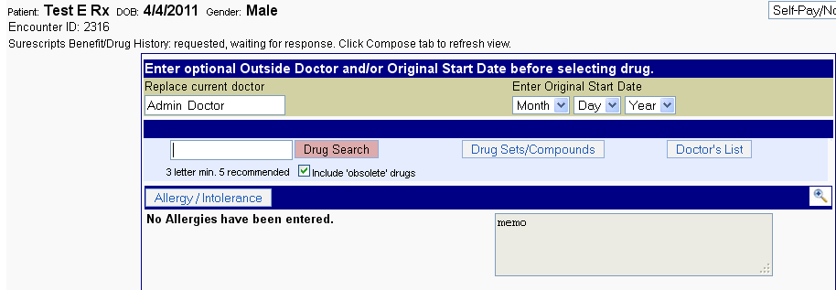

**Step 3**: - On clicking the search button, you get the list of the medicines with name starting with these letters, as shown below.

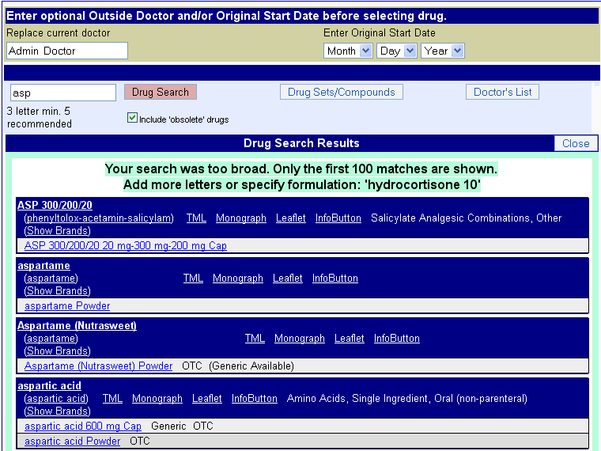

**Step 4**: - On selecting one of the medicines and clicking on the ‘Select to move to current Meds’ would move the medicine to the current medications.

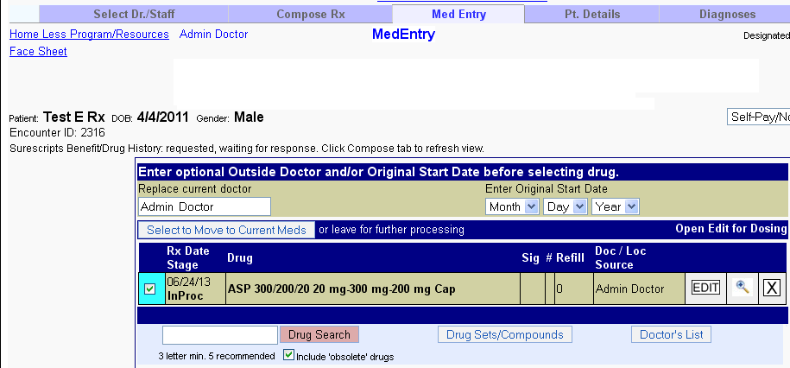

### 2.1.2) Importing medication from Sure Scripts.

Click on ‘Benefit/Drug history’.

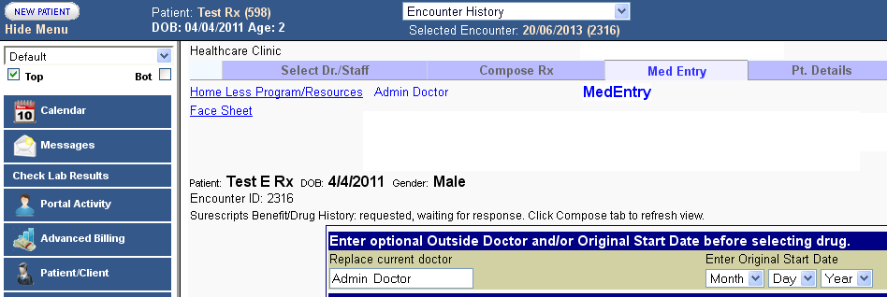

This would retrieve available drug history of the patient using Sure Scripts.

#### Entering a Sig

Create your prescription, see screen shot below. Make sure you click save this sig add to Doctors list, then click save Rx. By doing this the next time you do a drug search for this medication the sig is attached and there is no need to retype this information again.

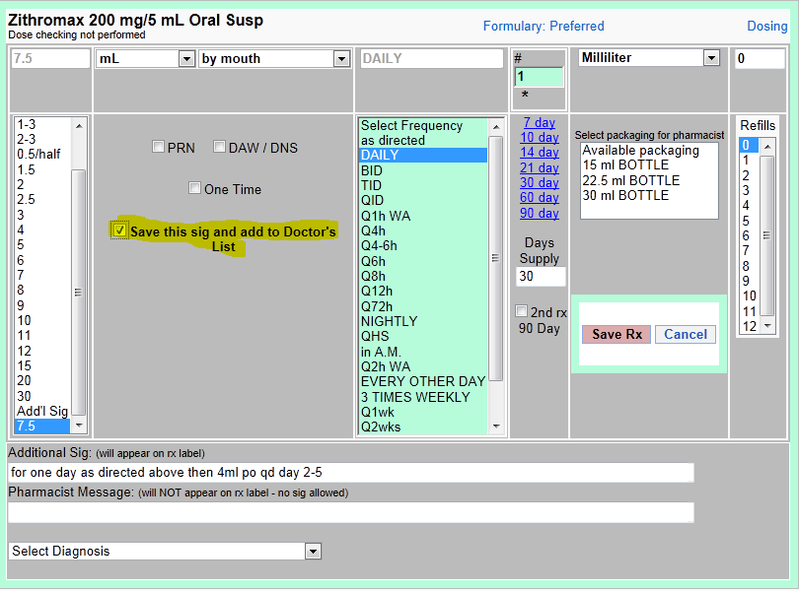

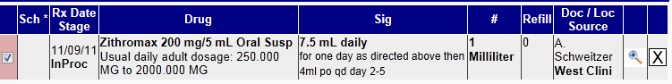

Pharmacy receives this Rx.



Next time a drug search is done you see this. Click on the drug with the sig attached, you do not have to retype this information in again. This information will also be saved in your Doctors list.

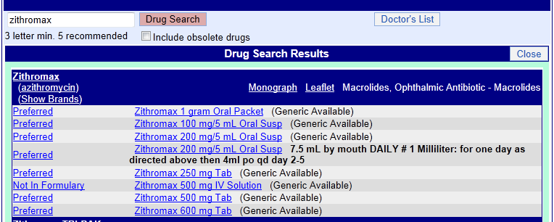

## 2.2) Prescribing new drugs (Compose Rx)

Compose Rx takes care of

1. Prescription writing.
2. Sending prescriptions.

### 2.2.1) Prescription writing

**Step 1**: - Click on the ‘Add/Edit eRx’ in the patient chart

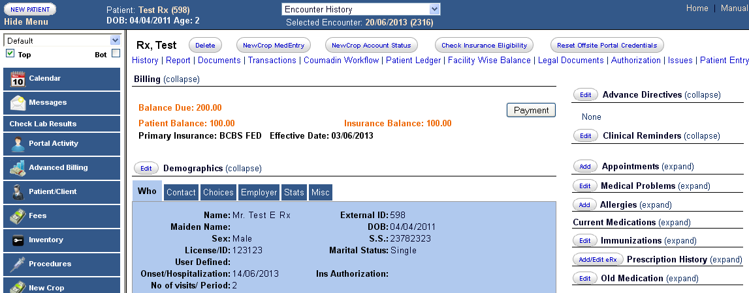

Then we come to the compose Rx page

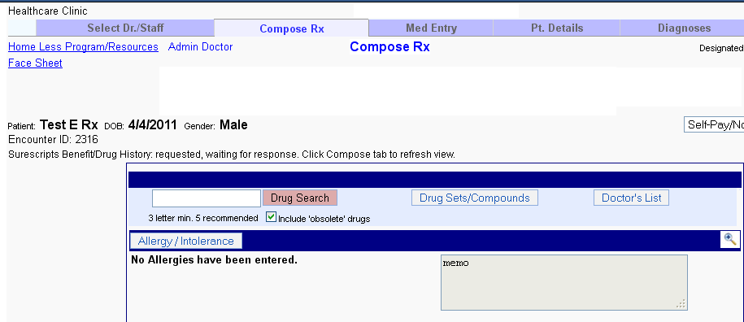

**Step 2**:- Type 3 to 5 starting letters of the medicine we want to prescribe and click on ‘Drug search’ to search for the medicine.

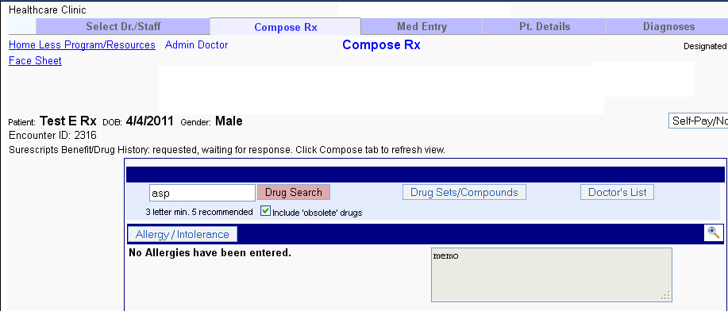

**Step 3**: - We get a list of drugs starting with those letters.

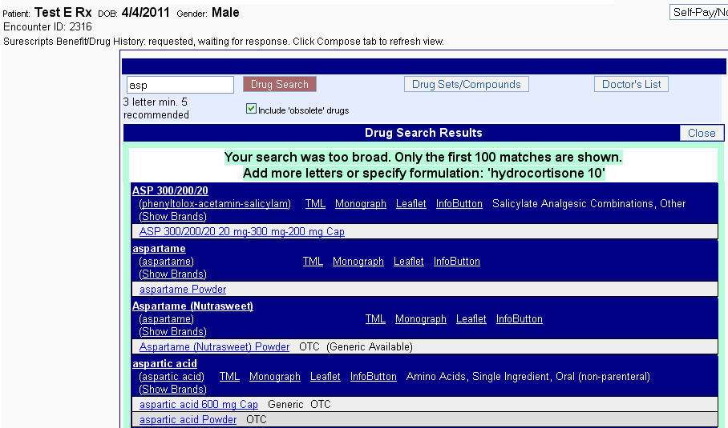

Select the drug which needs to be prescribed by clicking on it.

**Step 4**: - We come to the page where we can decide the dosage.

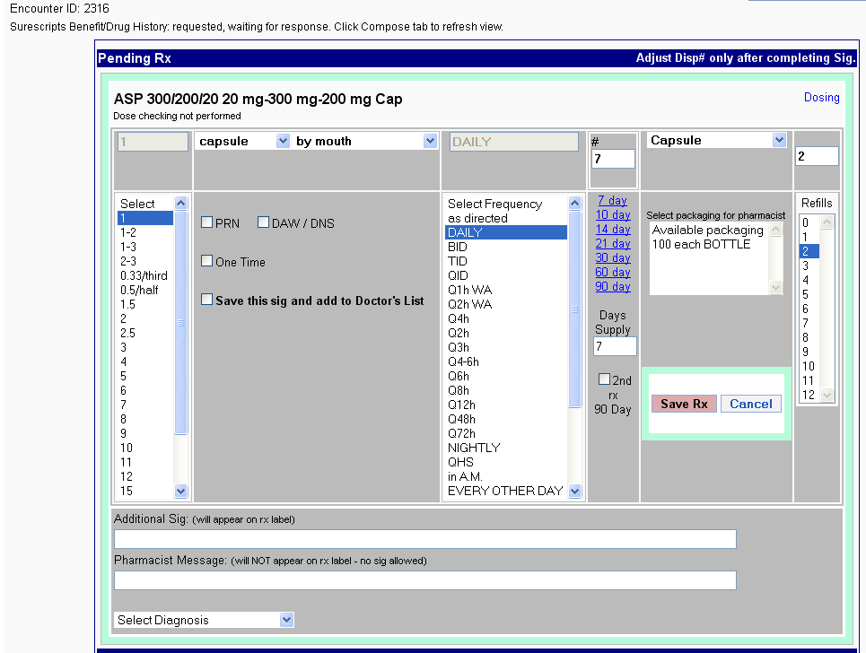

Select the dosage according to the needs and click ‘Save Rx’.

Now below we see the medicine added for prescription.

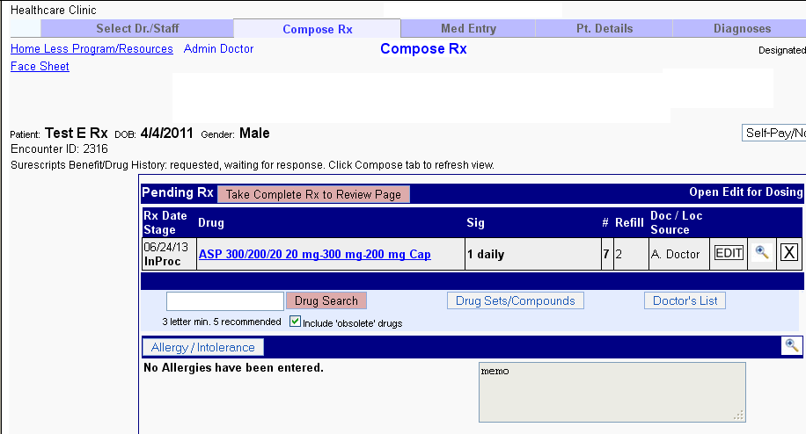

### 2.2.2) Sending prescriptions (Print)

**Step 1**: - Click on the ‘Take complete Rx to Review Page’ tab to go to the page where we can send the prescription to the pharmacy.

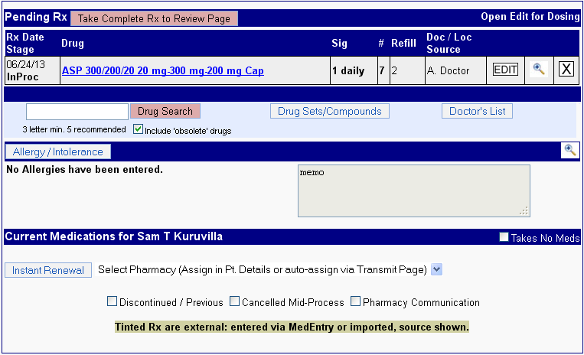

**Step 2**: - We can click on ‘Print Rx’ to prescribe through paper. Then we have to send the ‘print out’ to the pharmacy manually.

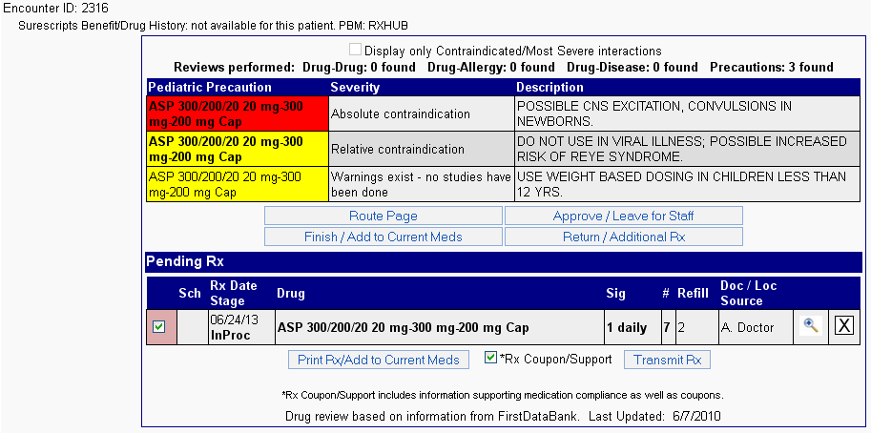

A print copy of the prescription would be as shown below

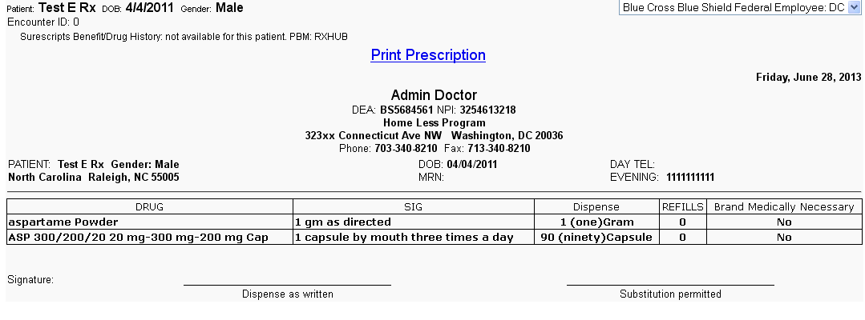

### 2.2.3) Sending prescriptions (Electronic)

**Step 1**: - Click on the ‘Take complete Rx to Review Page’ tab to go to the page where we can send the prescription to the pharmacy.



**Step 2**: - Click on transmit Rx to be able to choose the pharmacy to which we want to transmit the prescription.



**Step 3**: - We can transmit the medicine electronically to any of the pharmacies in the pharmacy list (In this case there is only one, so we don’t have a choice), by clicking on the pharmacy name.

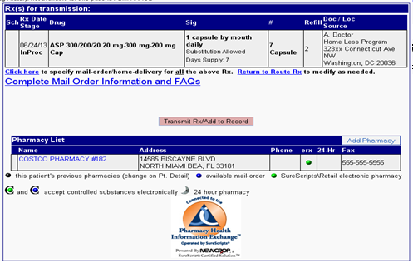

On clicking the pharmacy name, the pharmacy gets selected.

Thereafter we click on the ‘Transmit Rx/Add to Record button’

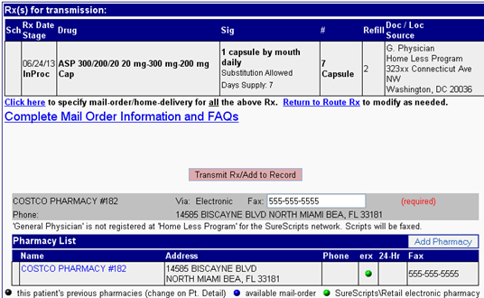

We can search for more pharmacies using the ‘Add pharmacy’ button.



**Step 8**: -Then click the ‘Transmit Rx/Add to Record’ (seen in the above screen shot). Then the Prescription gets transmitted as shown below.

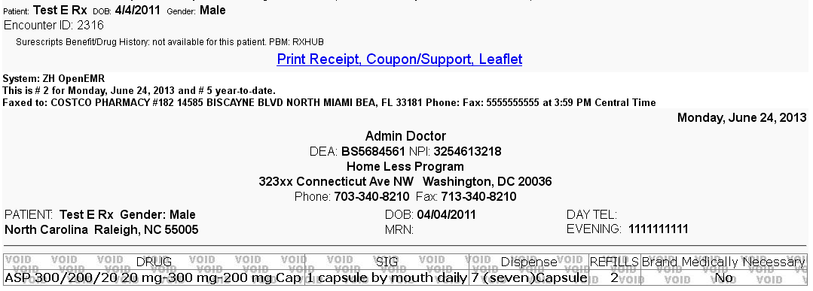

We can see the transmitted medicine if we expand the Prescription history on the patient chart.

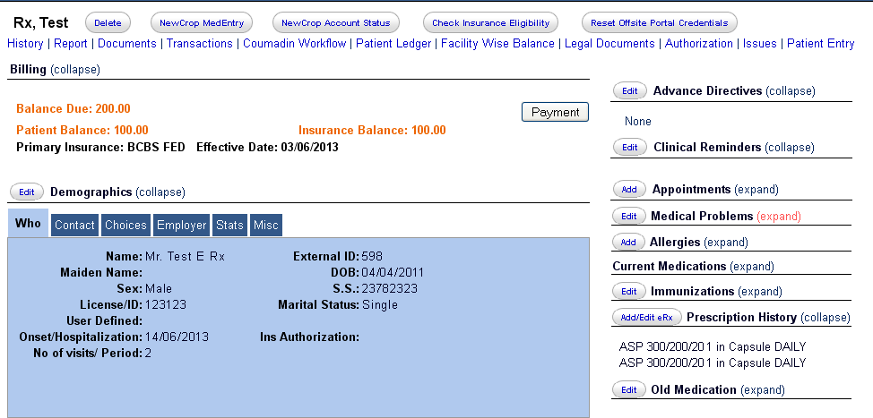

#### Entering a Sig

Create your prescription, see screen shot below. Make sure you click save this sig add to Doctors list, then click save Rx. By doing this the next time you do a drug search for this medication the sig is attached and there is no need to retype this information again.





Pharmacy receives this Rx.



Next time a drug search is done you see this. Click on the drug with the sig attached, you do not have to retype this information in again. This information will also be saved in your Doctors list.



## 2.3) Allergies

Allergies section takes care of

* Add Allergy information

**Step 1**: - Click on the ‘Add’ tab next to the allergies in the patient chart.

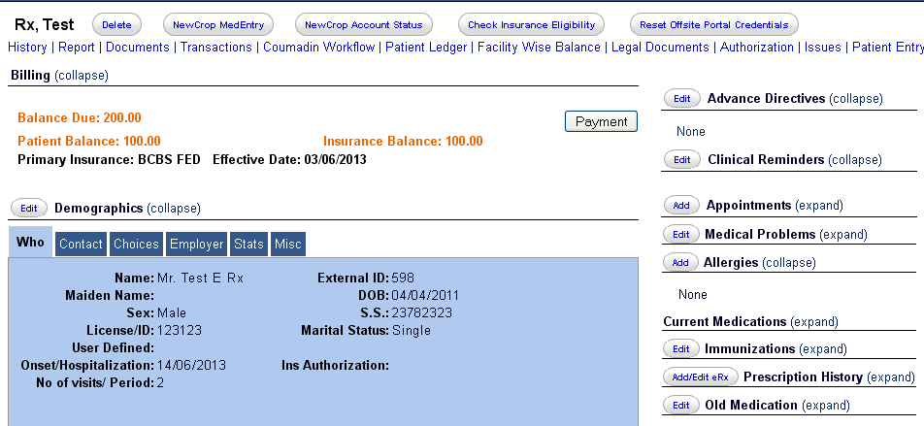

**Step 2**: - Click on the ‘Allergies/Intolerance’ tab shown below.

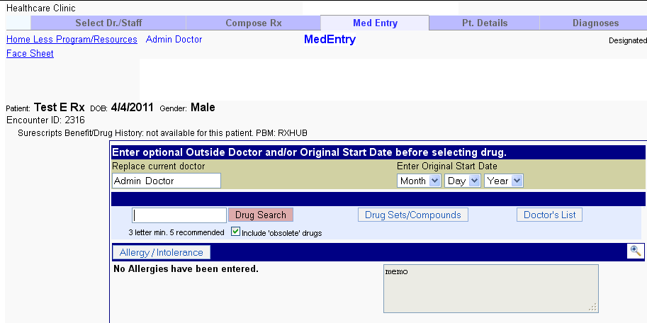

On clicking get the option to search for an allergy. We also get a list of common allergies also to choose from without searching.

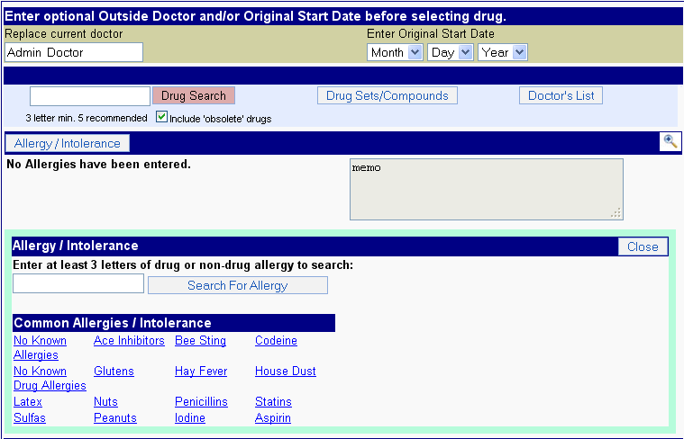

**Step 3**: - Type first 3 letters and click on ‘Search for Allergy’ to get the options to choose from.

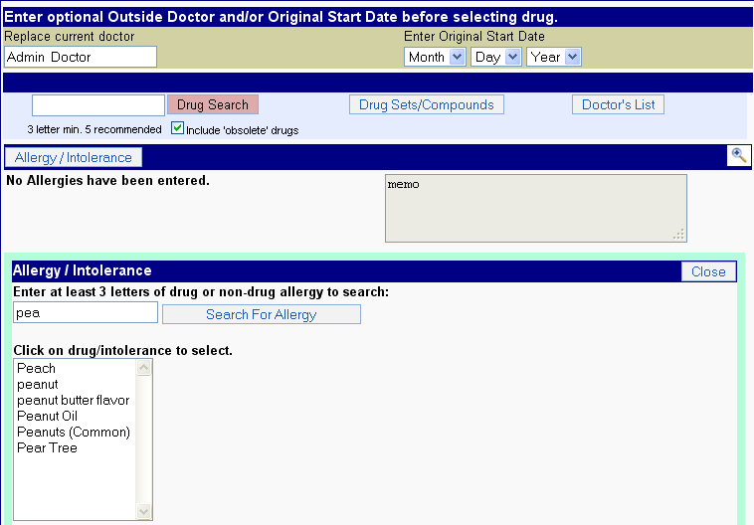

**Step 4**: - Choose one of the allergies listed. Then we get a drop box to select severity of the allergy and also enter a note. After doing so, click on the ‘Save Allergy’ tab.

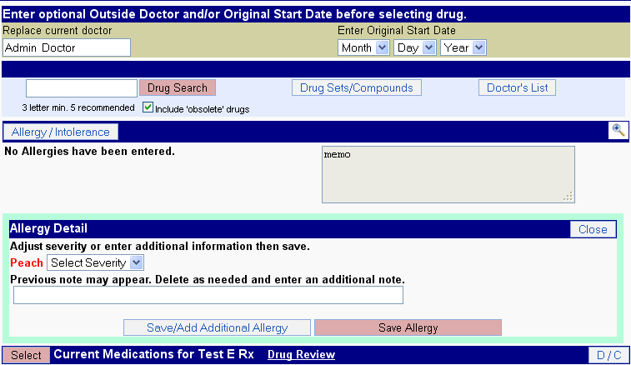

Now the following screen appears. The allergy along with the severity is entered.

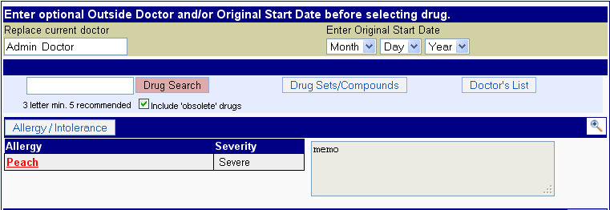

We can also find the allergy added in the patient chart, as shown below.

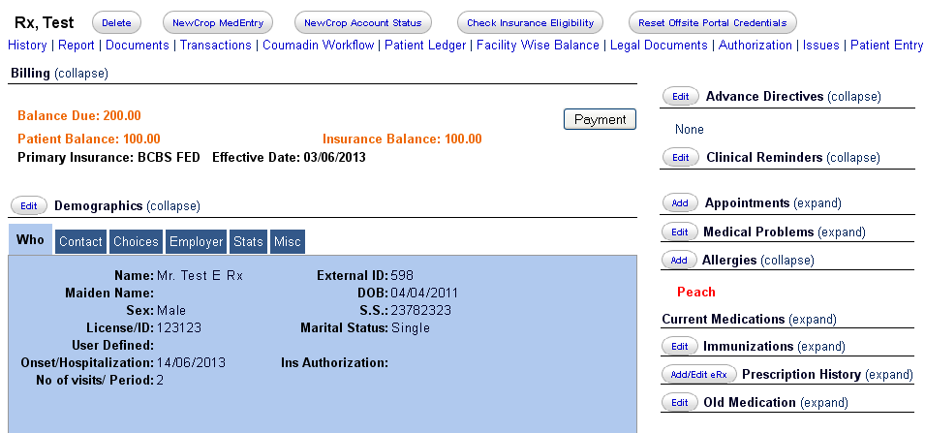

## 2.4) Handling renewals

### 2.4.1) Receive refill requests from pharmacy.

To check for refill requests from the pharmacy, we need to click on the link shown below.

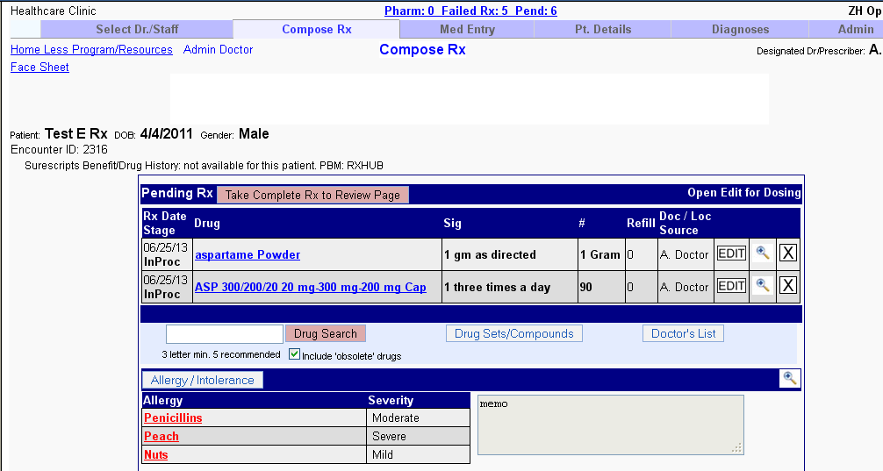

On clicking that we are taken to a page where we see the ‘Pharmacy Renewal Requests’. In this case there are none.

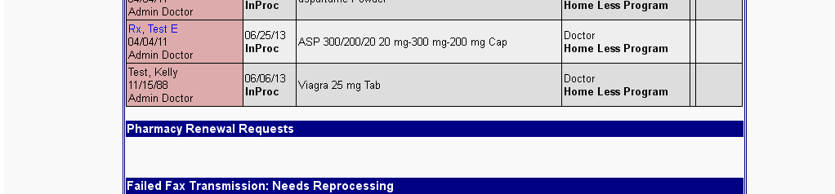

## 2.5) Other features

### 2.5.1) Automatic features

This module automatically shows.

* Drug to Drug interactions.
* Drug to allergy interactions.
* Drug Formulary Information.

### 2.5.2)To add a health plan manually

Click on the Admin Tab which comes on the screen after clicking the ‘Add eRx’ button in the patient chart.

Then click on the Account Health plan link:

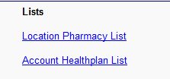

Click Add additional Health plan link:

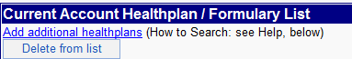

You will now see a list of health plans, this list is associated with what state you are prescribing in. My test doctor is set up in the state of TX so my list shows health plans in our data base in TX:

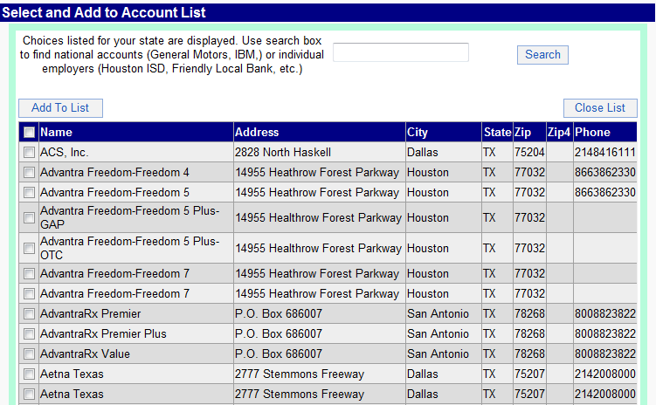

You can add all the health plans to your location by clicking the check box next to Name, this is our select all, or individually select the health plans then click add to list.

Once you have created your account health plan list. If using an EMR, leave NewCrop, find a patient, click back across to NewCrop then click on the Patient Details tab, this is where you can manually assign health plans to patients and receive the formulary checking. Once in the Pt Details tab you will see Healthplan/Insurance/Formulary box, in the primary section click on the drop down screen, here you will see the list of health plans that you have created from the Admin Tab. Select the health plan for your patient, then click Save/Go to Compose Rx.

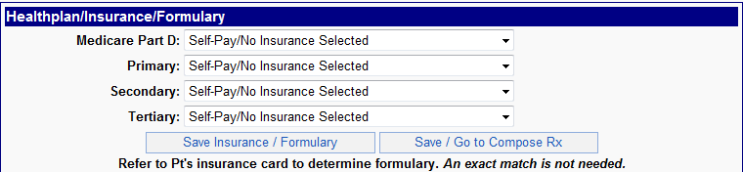

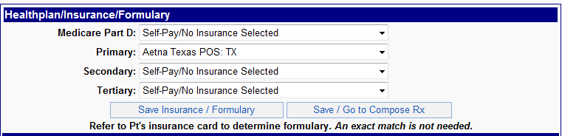

You should now see under the providers name in the upper right hand corner the insurance that you have assigned to this patient.

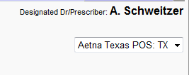

Now on the Compose Tab, search for a medication. You will see formulary checking done and displayed on the left side of your medication:

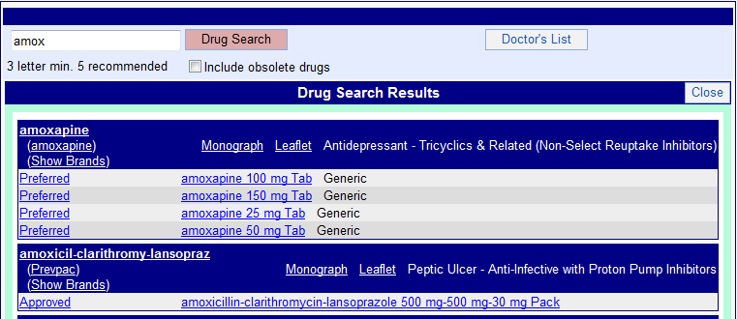

Preferred is the lowest tier of a patient insurance, EXAMPLE: PREFERRED is their $5 co-pay, Approved is the next tier this could be their $10 co-pay. You may also see not reimbursed, not in formulary, not approved etc.

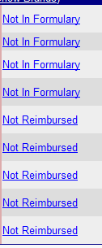

If you see this click on any of the formulary links you will see a pop up box containing therapeutic alternatives for that medication; a pop up box will open and display medications that are covered by this patients insurance. Click on the medication you would like to prescribe that may be covered under the patients insurance:

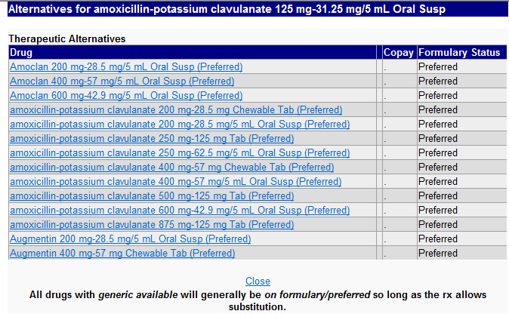

Once you select your medication, create your Rx then transmit to the pharmacy.

### 2.5.3) Reporting and retransmitting missing prescriptions

When checking the status of a routed RX, follow the steps below:

Click on the magnifying glass to the right of the medication in the current med list, this will open RxDetails:

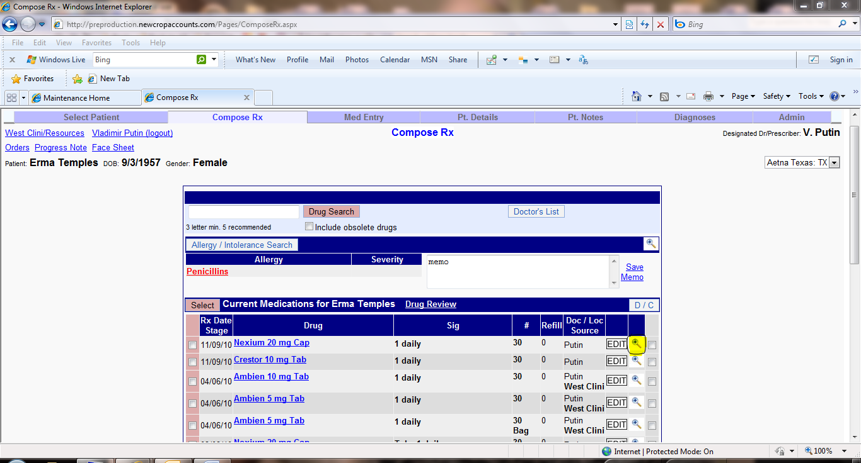

Scroll down until you see the print/transmission log. The information in this section will tell you when the RX was routed, who routed the RX, how it was routed, ie: electronic, fax, RxHub or print, where the Rx went to and the status. If an RX was sent electronically you will see the report missing Rx button and a free text box to the left of that button. If a pharmacy calls and says they did not receive the Rx, you must type in who you spoke with at the pharmacy then click report missing Rx. This will generate an email to SureScripts for research. As per SureScripts if an Rx was sent electronically and you see a verified and or a success 99.9% of the time the pharmacy received the Rx and it is a pharmacy training error. This is why we always ask who you spoke with at the pharmacy so that they can receive the proper training on how to use their system. Once we receive the findings back from the pharmacy that will be emailed back to the EMR vendor to share with the provider. If an RX was routed to a pharmacy by fax, I CANNOT research a fax; provider/nurse will need to retransmit the fax again to the pharmacy:

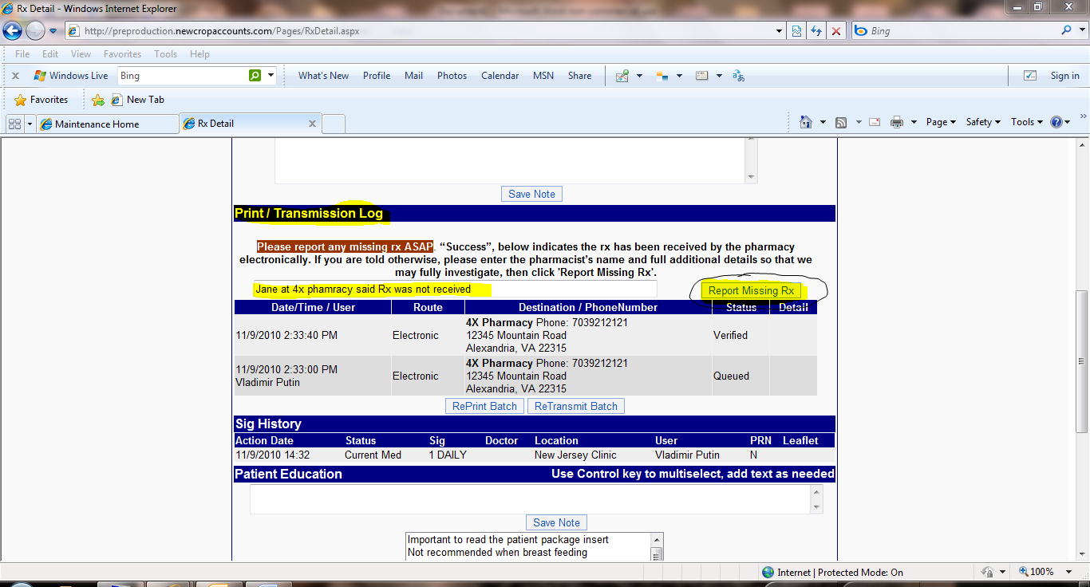

After you have filled in the information and clicked report missing RX you can now retransmit the batch to the pharmacy again by clicking the retransmit batch button, then transmit add to record. This will resend the Rx to the pharmacy:

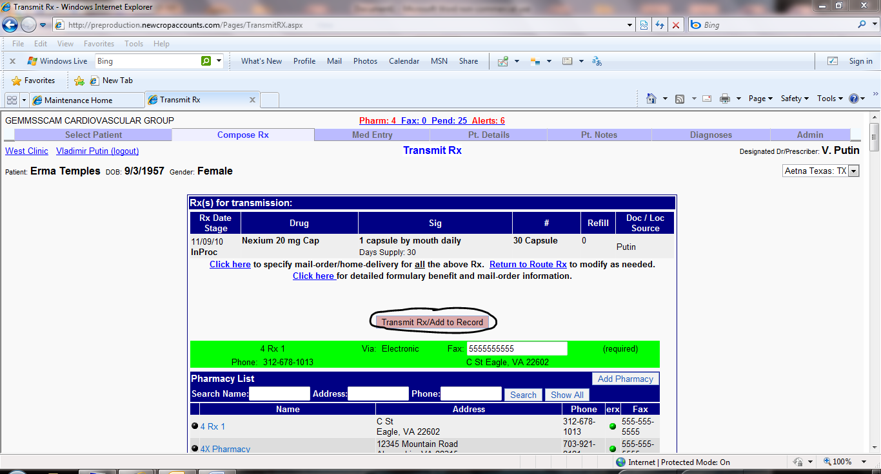

### 2.5.4) How to create and use drug sets

Creating drug sets allows providers to create a set of medications based off a diagnosis or create a set of compounded medications. Much like the Doctor’s List, this feature saves the medication with sig for repeated use. Drug sets allow providers to prescribe a group of medications efficiently, and creates a standardized drug selection. Drug sets are maintained by account and are available for use by any user at any location.

Click through to the NewCrop screens, click on the Drug Sets button:

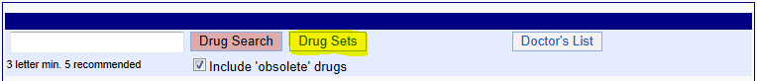

Click on the link: **Maintain Drug Sets**



Click on the link: Add additional drug set

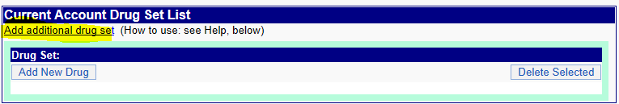

Type in the name of the diagnosis or the name you would like to call this drug set, click Add Drug Set

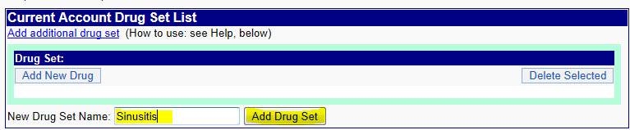

Now click select next to the name of the drug set you have just add, then click Add New Drug.

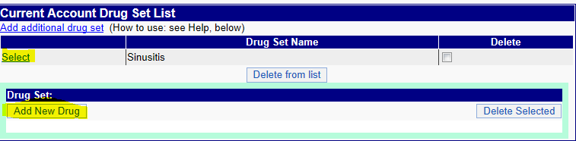

Type in the name of the drug you would like to add and click Search, then select the medication you would like to add.

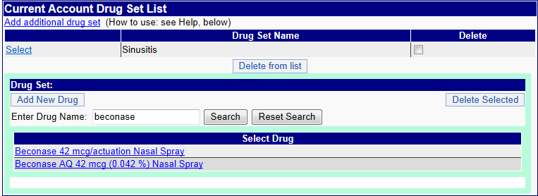

Once you click on the medication the Edit screen will open up. Write the prescription as you normally would and click Save Rx.

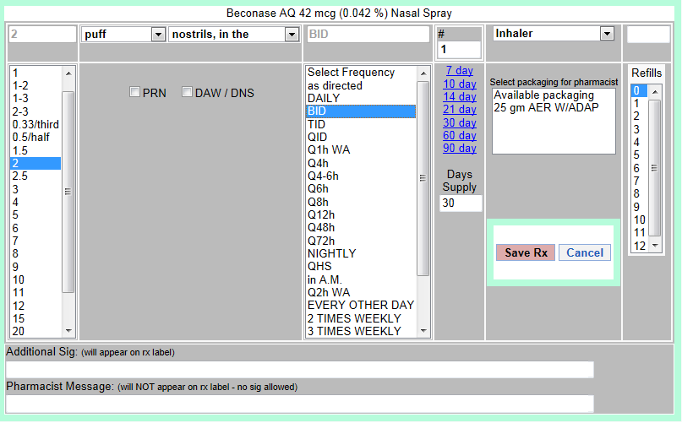

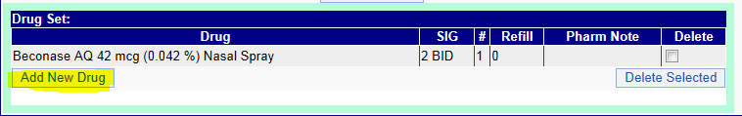

You will see the medication you have created in your list, click Add New Drug to add more to your drug set list.

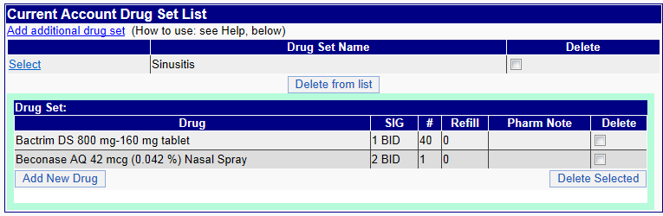

If you would like to add more drug set lists follow the steps above to create.

Once you have finished creating your drug set lists, click over to the Compose page and click on your Drug Sets button. There you will see the list of drug sets you have created. Click select next to the drug set name.

The list will be placed at the top of the page:

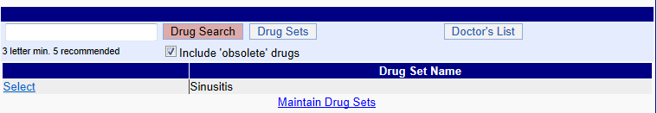

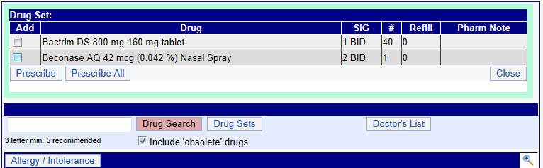

Prescribe All these medications with the sigs that you have created will now be pending (InProc). Process the prescriptions normally to transmit to the patient’s pharmacy.

Alternately, you may check individual drugs you would like to prescribe from the drug set.

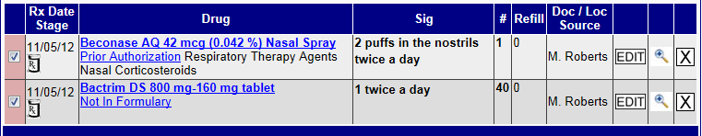

### 2.5.5) Adding or editing location pharmacy details

Click on the location pharmacy list link shown below.

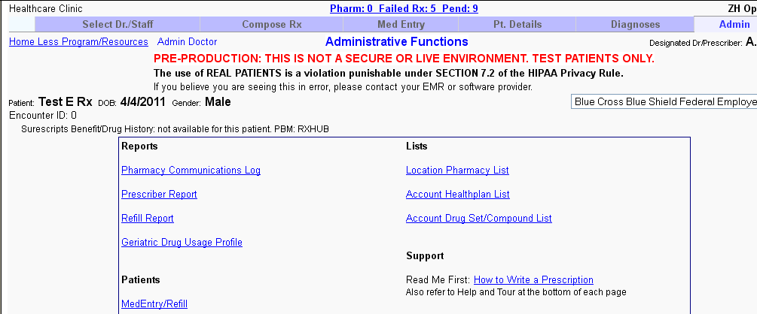

We go to a page shown below. Here we can add a pharmacy by clicking the ‘Add pharmacy’ button, or edit the fax number of an already existing pharmacy, by clicking on the pharmacy name.

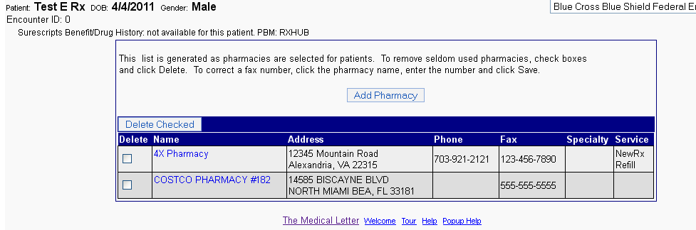

### 2.5.6) Leaving for staff processing

When a provider does not want to go through process of selecting the pharmacy for prescribing a drug, the provider can choose to leave the processing of the prescription to the staff at the facility.

In the review Rx page in a providers login, there is a tab ‘Approve/Leave for staff’

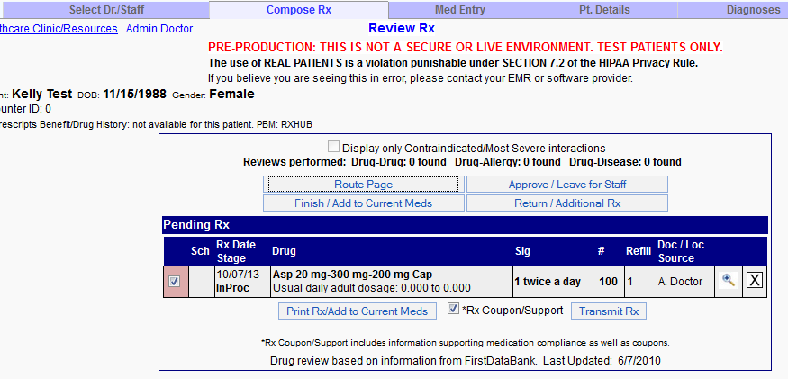

Once this button has been clicked, we can see this drug in the list for staff processing. We need to click on the below showed link, to view the staff processing list.

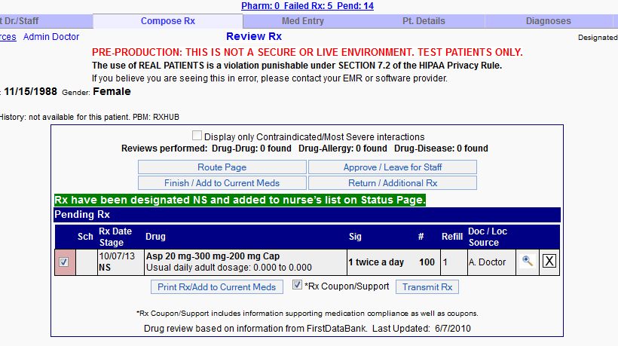

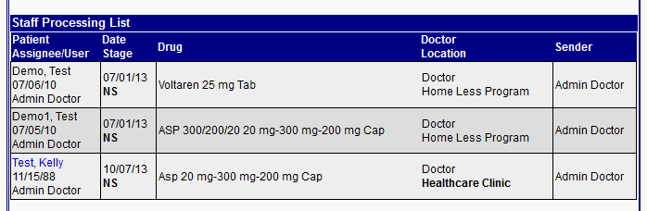

Now when the staff logs in, they can go ahead and complete the prescription process, as advised by the doctor through their logins.

### 2.5.7) Leaving for doctors approval

When a front office staff does the job of selecting the drug for a patient and wants to leave it for doctor’s approval. In his/her user, in the Review Rx page they will have the option ‘Leave for Doctor Review’.

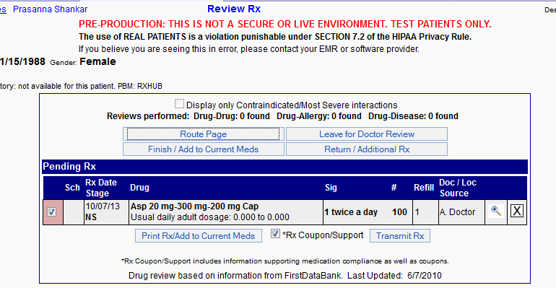

Now on clicking the below shown link, we can see the above prescription being added to the doctors review list

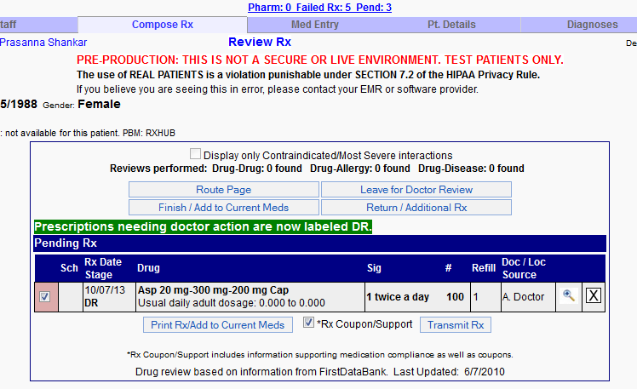

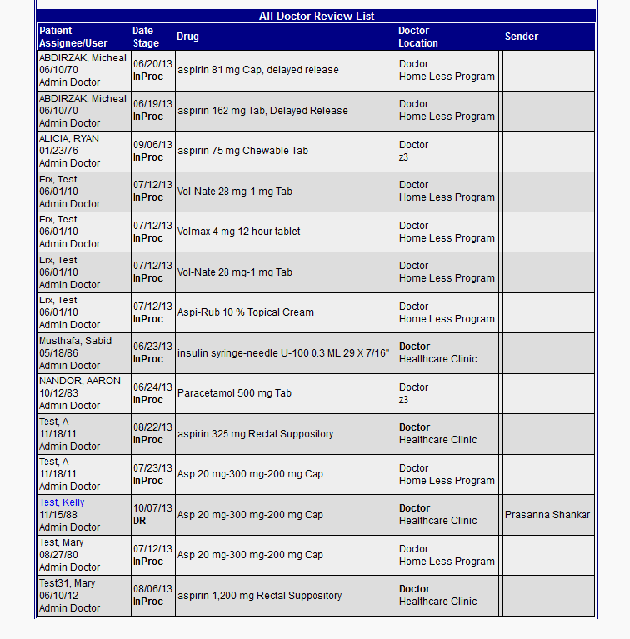

Now when the doctor logs in, they can go ahead and approve the prescription left for their approval by the nursing staff. In the Review Rx screen, the doctor will have the option to approve.

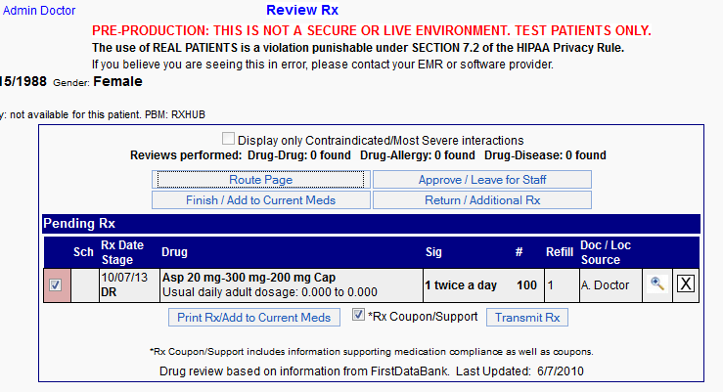

### 2.5.8) Other features under the ‘Admin’ tab in the Prescription page

Under the Admin tab in the prescription page, we have the option to print reports, get further support and orientation views etc.

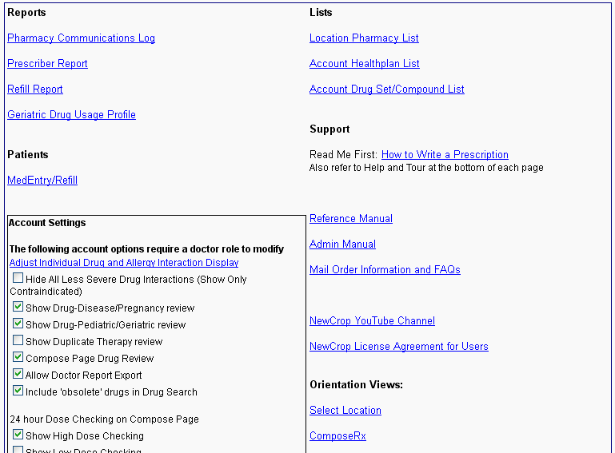

# 3. FAQ

1) How do you prescribe a dosage that is not in the drop down list given by default in Newcrop

Providers can change the dosage screen to additional sig, type in the amount they choose in the additional sig line.

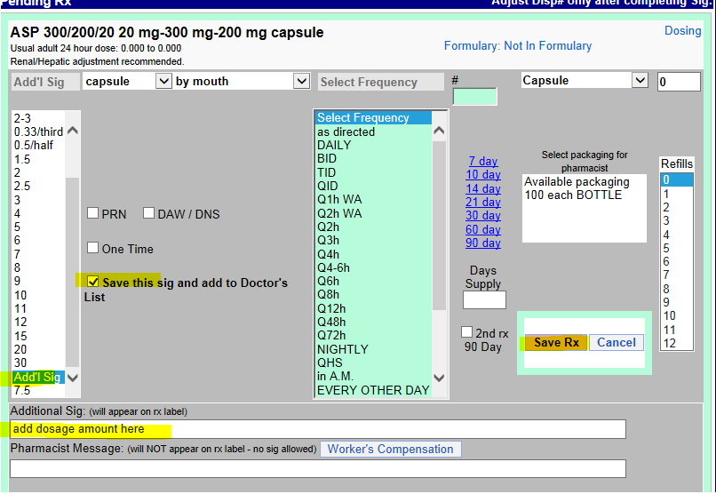

2) How to find the date the prescription was changed or discontinued

If we click the check box ‘Discontinued/Previous’, we get the full list of discontinued drugs for this patient. On clicking the magnifying glass to the right, you can find the history of this drug.

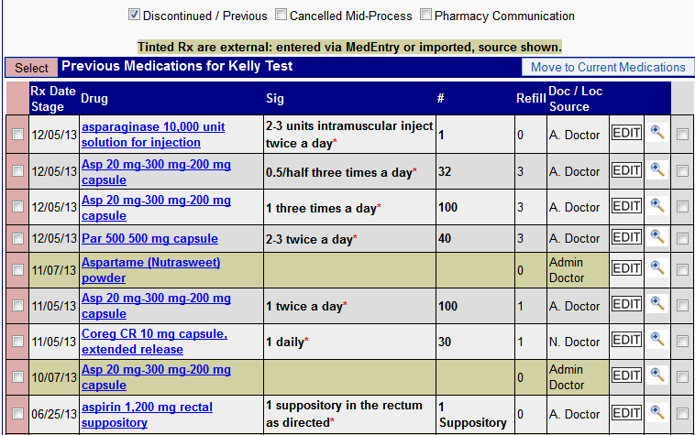

We find the sig history as follows

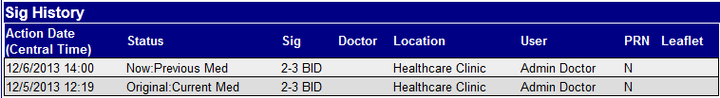

3) How to find the pharmacy to which a particular drug was prescribed to

Click on the glass button to the right of the drug on the current medication

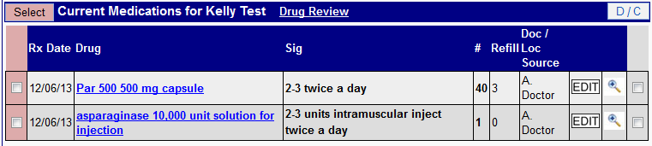

On clicking you go to the following screen where we will find the print/transmission log, which will give the name of the pharmacy

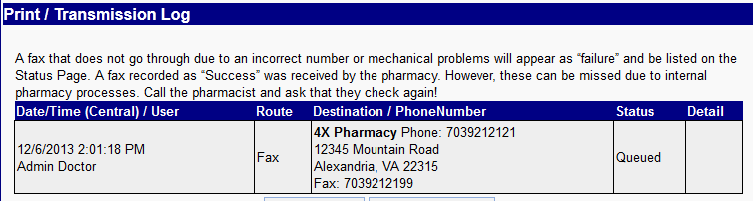

4) Where do we find the patient pharmacies?

First we need to click on the patient details tab shown below. There we see the patient pharmacies and we also get the option to add more pharmacies.

